Enhancement 2 – Algorithms and Data Structures
For this second enhancement, my plan included:
- Adding functional filters to the data
- Adding dynamic search
The original artifact was from a dashboard/database project from CS340: Advanced Programming Concepts (Client Server Development). The purpose of the dashboard requested by Grazioso Salvare was designed to allow the user to filter and display data based on specific animal criteria from the Austin Animal Center. The developed dashboard included a filterable table, four filters, a dynamic map, and a pie chart that updated along with the selected filters.
I selected this item for this enhancement because I felt confident that it would showcase my ability to develop customer requirements like filters and quick search capabilities on a functioning site that had several dynamic components. This artifact is a continuation of the original artifact from the first enhancement and has been improved to incorporate the required functionality.
I feel that I did meet the course outcomes I had planned to meet for the second enhancement. I achieved the outcomes of “Design and evaluate computing solutions that solve a given problem using algorithmic principles and computer science practices and standards appropriate to its solution, while managing the trade-offs involved in design choices” and “Demonstrate an ability to use well-founded and innovative techniques, skills, and tools in computing practices for the purpose of implementing computer solutions that deliver value and accomplish industry-specific goals” by fully implementing the requested “set” filters, along with adding dynamic searching of the data from the MongoDB database. Instead of utilizing static data structures to hold animal and user information from within the code, I chose a more scalable database structure (MongoDB) that is accessible on the backend by admin. I was also able to connect the filtering and searching function to the pie chart and map, so they are all showing the same searched data. The remainder of this enhancement will be completed prior to the final submission and include tying in the filters/search to also reflect in the pie chart and map.
This enhancement was also a major challenge for me in this project. The first hurdle I found was getting the table to populate the data from our database, which took several attempts. The more complicated challenge was getting the data to filter as expected, which required me to move around files in the directory, adjust routing information because it was creating a new server instead of using the existing one, and learn how to troubleshoot in stages with console logs to see where the flow was breaking. I had originally thought it was the back end, but everything was connecting as expected. It ended up being a routing issue and it was talking to incorrect files. Once I was able to resolve the paths, adding the search dynamic search functionality was easier.

(Original Dashboard Artifact)
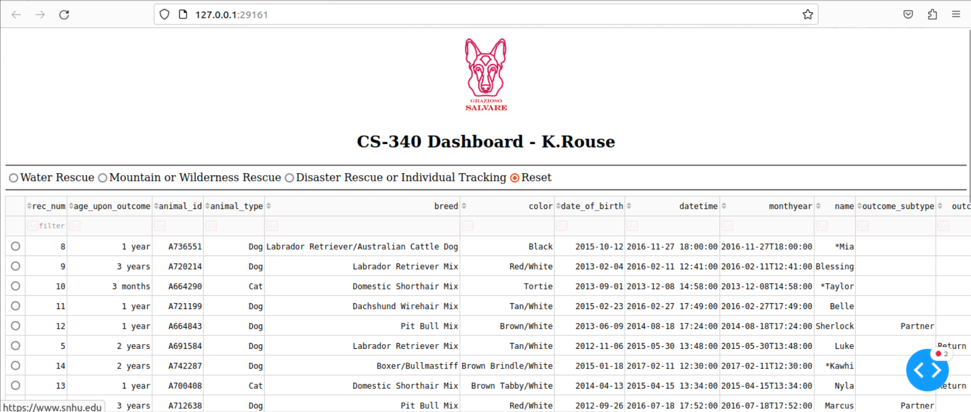
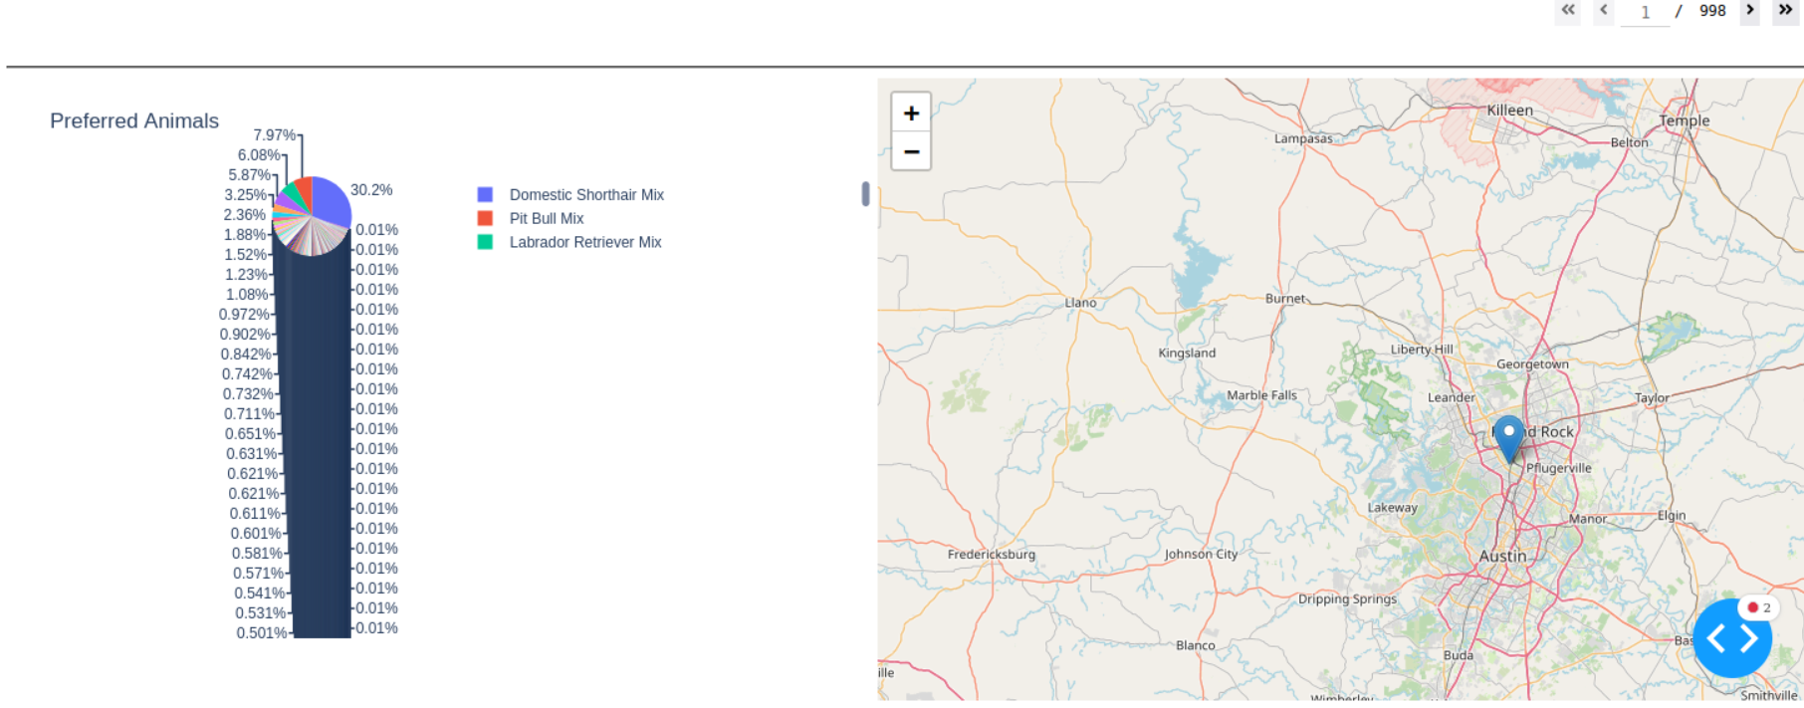

Austin Animal Center - Filter off (ALL)
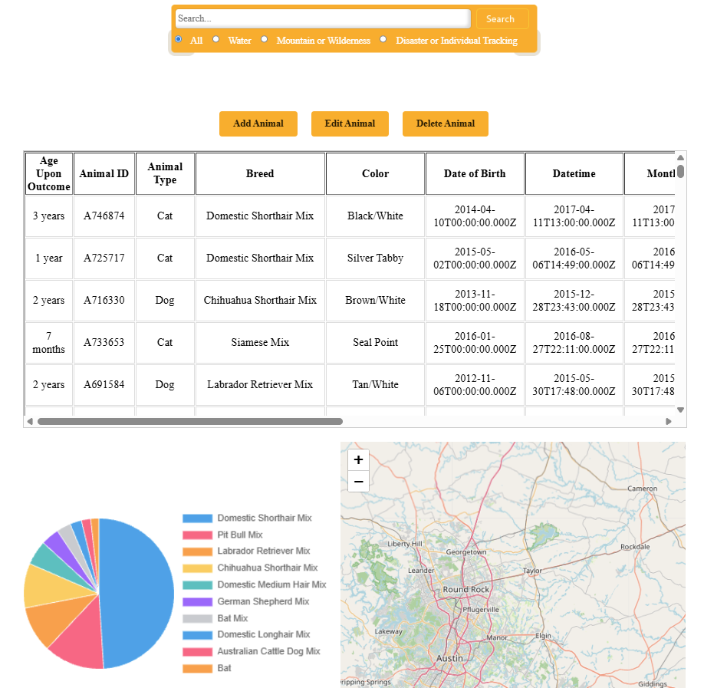

Austin Animal Center - Water Rescue Filter
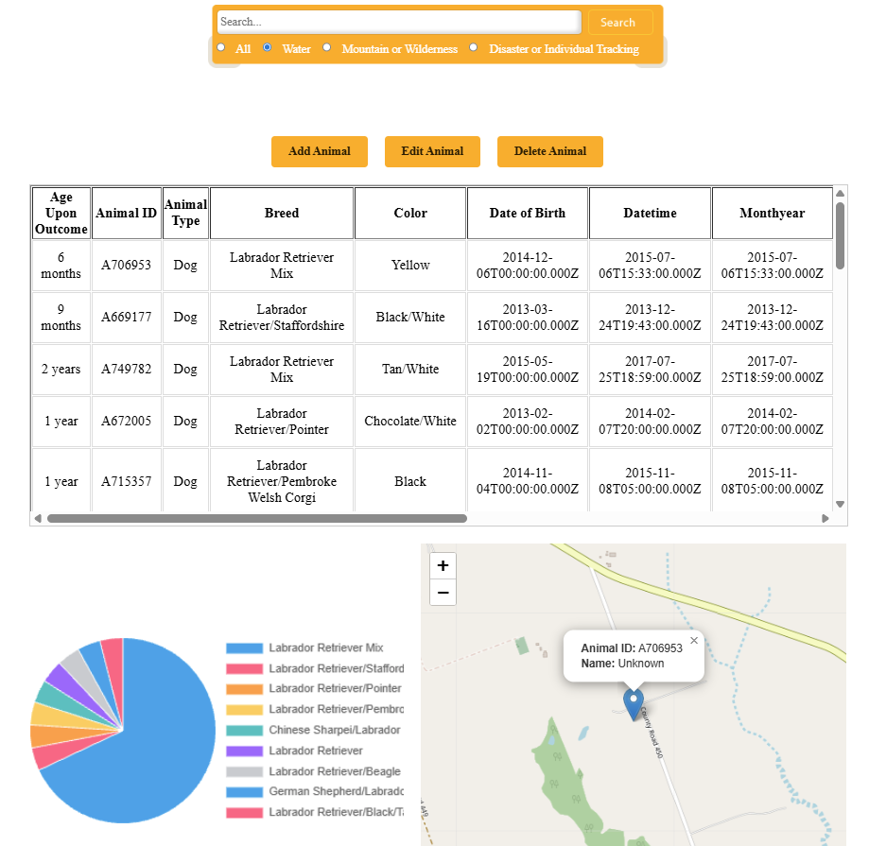

Austin Animal Center – Mountain or Wilderness Rescue Filter
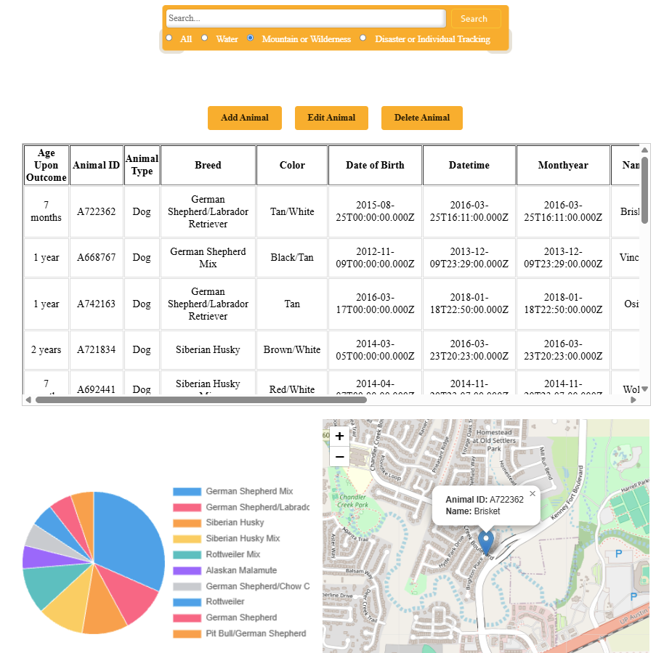

Austin Animal Center – Disaster Rescue or Individual Tracking Filter
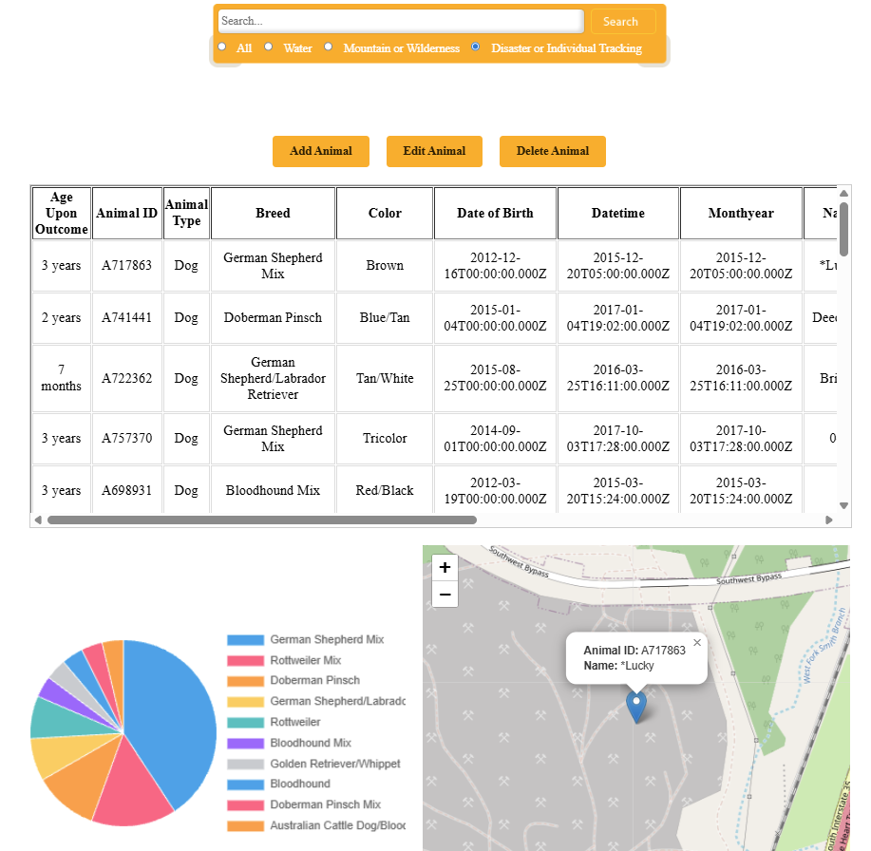

Austin Animal Center – Using the text search option
